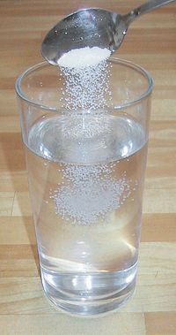

One of the common mixtures you will use in Science is the solution. A solution is a type of mixture containing a solute dissolved in a solvent. A solute is a solid which will dissolve in a solvent, and the solid is said to be soluble. A solvent is a substance which will dissolve a solute. For example, when sugar dissolves in water, sugar is the solute and water is the solvent. A substance which dissolves in another is said to mix evenly into it. A solid which will not dissolve in a solvent is said to be insoluble. Two liquids which mix evenly in with each other are said to be miscible. Two miscible liquids are petrol and kerosene. Two liquids which will not dissolve in each other are called immiscible. Petrol and water are immiscible.

1. Complete the following for the words, soluble and miscible.

Vocabulary
What does it mean? Find a word that is:
Similar

Opposite
Word: SOLUBLE

Use it in a sentence Draw a picture of it

(4 marks)

Vocabulary
What does it mean? Find a word that is:
Similar

Opposite
Word: MISCIBLE

Use it in a sentence Draw a picture of it

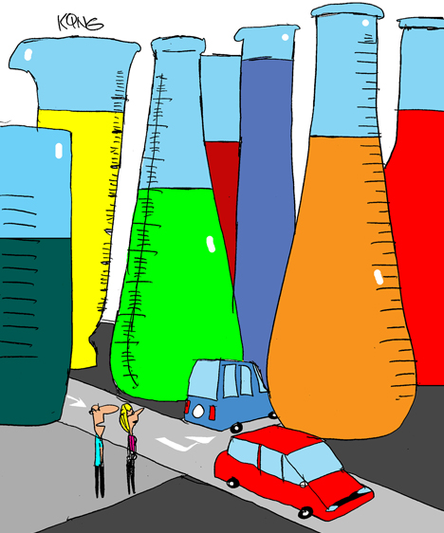
(4 marks)

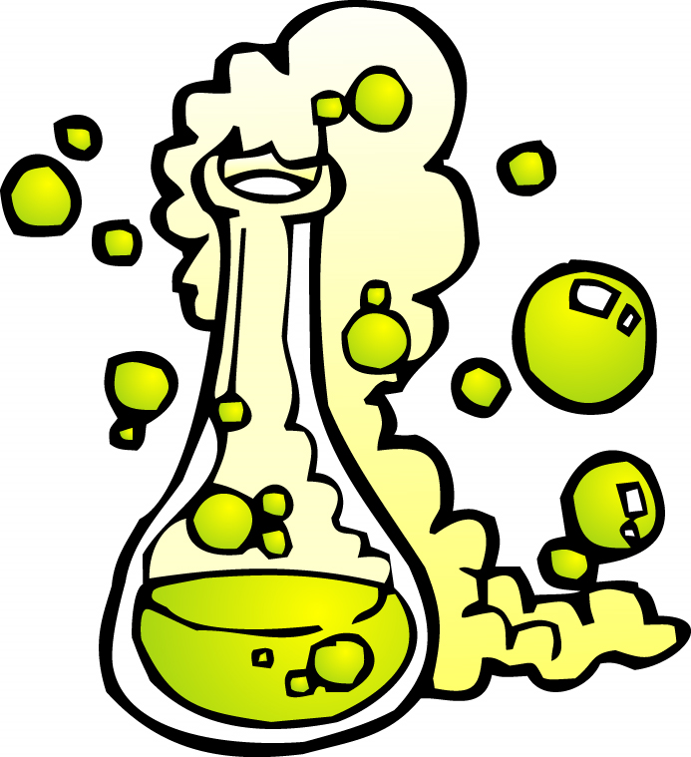
Complete the following table using the paragraph on the previous page:

Term (Word) | Definition
Solution
Solute
Solvent
Insoluble
Dissolve
Immiscible
(6 marks)

SOLUBILITY

Substances are soluble if they dissolve in a solvent. Substances are soluble if the forces holding their particles together are weaker than the forces between their particles and those of the solvent.

Substances which do not dissolve in a particular liquid are said to be insoluble in that liquid. Substances are insoluble if the forces holding their particles together are stronger than the forces between their particles and those of the solvent.

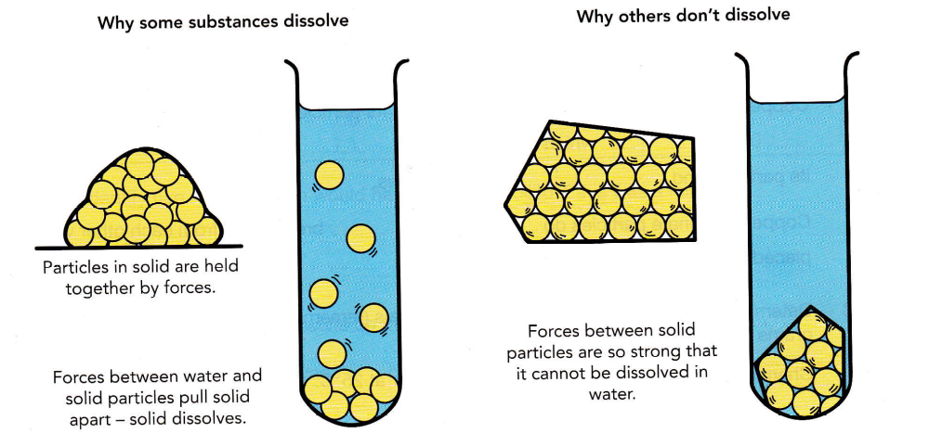
The solubility of a substance is a measure of how much of it dissolves in 100mL of water at 25ºC.

Complete these sentences to explain why some substances are soluble and others are insoluble. Use the following words:
chemical, particles, water, forces, chemical, strength, particles

1. When a chemical is put in water, three sets of forces act between particles.

There will be forces of attraction between the water __________________ and the particles of the ____________________.

There will be forces of attraction between water __________________ and other
___________________ particles.

There will be forces of attraction between the particles within the ____________
itself.

Whether or not the chemical dissolves depends on the _____________________
of each of these three _____________________ .
(6 marks)
water, chemical, attraction

2. If the force of ______________ between ______________________ particles and the particles of the ___________________ is greater than the other two forces, then the chemical will dissolve.
(3 marks)
other, tightly, dissolve, will, each, not

3. If the particles of the chemical are held together so _____________ that the water particles cannot break them away from_________________ _______________ then the chemical ______________ __________________ _______________.
(6 marks)
particles, soluble

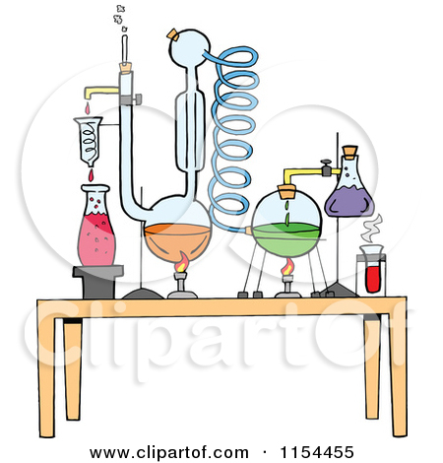

4. Sodium chloride (common salt) is ____________________ in water because its _____________________ break away from each other when it is put into water.
(2 marks)

GRAPHING

5. The table shows the results of an experiment done to examine how the solubility of three different chemicals changed with temperature. Use them to answer the questions.

Temperature (ºC) | Amount of chemical dissolving in 100mL water
Temperature (ºC) | Chemical A | Chemical B | Chemical C
10 | 3.1 | 8.2 | 0.4
20 | 4.0 | 7.3 | 0.8
30 | 4.7 | 6.7 | 1.2
50 | 5.8 | 5.5 | 2.6
60 | 6.3 | 5.0 | 3.6
70 | 6.7 | 4.5 | 4.8
80 | 7.0 | 4.2 | 6.6
100 | 7.1 | 3.5 | 12.0

- Graph the three sets of results on the one graph. (line graph)
(5 marks)
(ii) Identify two things that would have been controlled if this was a fair test.
____________________________________________________________
____________________________________________________________
(2 marks)
(iii) Which of the chemicals is most soluble at:

- 35ºC __________________
- 65ºC __________________
(2 marks)

(iv) If you have 1 litre of water. At what temperature could you dissolve:

- 58g of A ________________
- 42g of B ________________
- 26g of C ________________

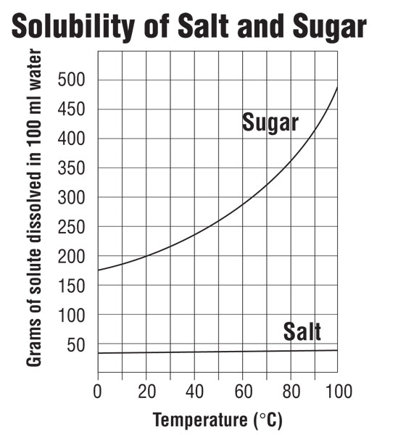
(3 marks)

- What mass of A would dissolve in 1 L of water at 35oC? ______________

- What mass of B would dissolve in 1 L of water at 45oC? ______________

- What mass of C would dissolve in 1 L of water at 55oC? ______________
(3 marks)

(viii) At what temperature is B twice as soluble as A? _____________________

(ix) At what temperature is C half as soluble as B? ______________________

- At what temperature is B three times more soluble than C? ____________
(3 marks)


